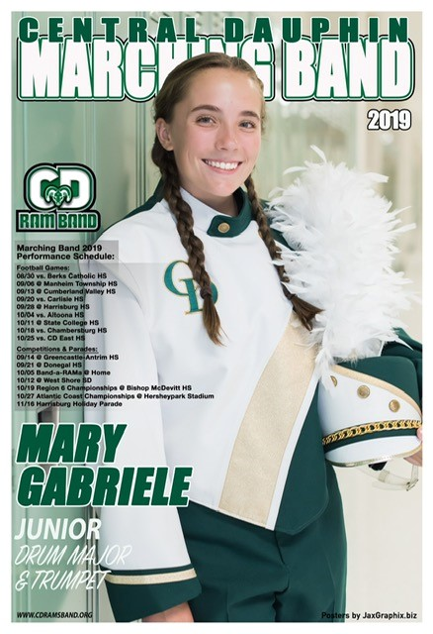
2020 SEASON POSTER

Fundraiser
The 2020 Marching Band season will be one that our students will remember forever! Because of the pandemic, students will not wear the regular uniform, rather a uniquely designed shirt, along with a matching neck gaiter for each will be ordered.
Once they arrive, PHOTOS WILL BE TAKEN during an upcoming band rehearsal. On this flyer, please find an image of last year’s poster. We will endeavor to ensure this year’s is just as special!

SELLING PRICE: $20/poster (Minimum order of 2 posters)
- Posters are 13" x 19", printed in full color on glossy card stock and include student’s name, class, and instrument (sample shows schedule which will not be included this year).
- Consider selling to employers, local businesses, friends, and family. They are a great way to display RAM pride, showcase the school and music program.
- Digital image included with purchase.

- Posters delivered approximately 2-4 weeks after photos taken.
- Completed ORDER FORM & PAYMENT DUE: Thursday, October 1st. You can scan or take a photo and email form to Amy Gabriele at jagabriele@comcast.net or return to Mr. Tate or Mr. Bitner. Cash accepted. Checks payable: CD Band Boosters; You may also pay by PayPal/Credit Card through our website, www.cdramband.org.
- Questions? Contact: Amy Gabriele at jagabriele@comcast.net or 717-329-9657.

CDHS Marching Band
2020 SEASON POSTER FUNDRAISER | ORDER FORM
Student’s Name:
Clearly write student’s name EXACTLY how you would like it to appear on the poster.
Please circle: Class Year: Freshman / Sophomore / Junior / Senior

 | QUANTITY*  (Circle minimum quantity or, indicate how many you would like to order) | AMOUNT DUE  Quantity X $20
 | 2 or ______ *Minimum order quantity is 2. | $

Completed ORDER FORM & PAYMENT DUE: Thursday, October 1st. You can scan or take a photo and email form to Amy Gabriele at jagabriele@comcast.net or return to Mr. Tate or Mr. Bitner.
Cash accepted. Checks payable: CD Band Boosters; You may also pay by PayPal/Credit Card through our website, www.cdramband.org.

Parent/Guardian Contact Information Cell # & Email: _______________________________

ALL monies profited will go to the CD Band Boosters general fund.

